Final Project: Data Analysis Report
NAME
Southern New Hampshire University

Findings
Based on the columns present in the dataset, the only two logical columns to be used for comparison are temperature and rainfall. The calculations for USA temperature/rainfall are:
- Min Temperature = -6.8235
- Min Rainfall = 27.40
- Max Temperature = 21.4416
- Maximum Rainfall = 85.12
- Average Temperature = 7.5545
- Average Rainfall=56.11
The GBR temperature/rainfall data statistics are
- Min Temperature = -0.1819
- Min Rainfall = 19.42
- Max Temperature = 17.3942
- Maximum Rainfall = 233.08
- Average Temperature = 9.1550.
- Average Rainfall=104.00

Informed Conclusion

- There are much more temperature differences in the USA than in Great Britain.
- USA experiences much cooler temperatures on average than Great Britain.
- Great Britain has an average of 47.89mm more rainfall than the USA.
- There is a relationship between the temperature and rainfall.The higher the temperature the ore the amount of rainfall.

Future Analysis
Based on the data present and analysis , a future analysis of the dataset can be done to estimate the months which heavy rainfall will be expected or when the temperatures will be at extreme levels so as to give guidance to all interested parties to make early preparations to ensure resilience. Using further statistical analysis on the dataset more informed analysis can be performed to determine how temperature affects the amount of rainfall.

Command Line Interface
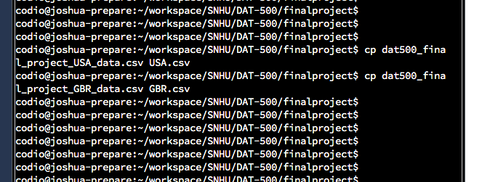
Fig 1.0

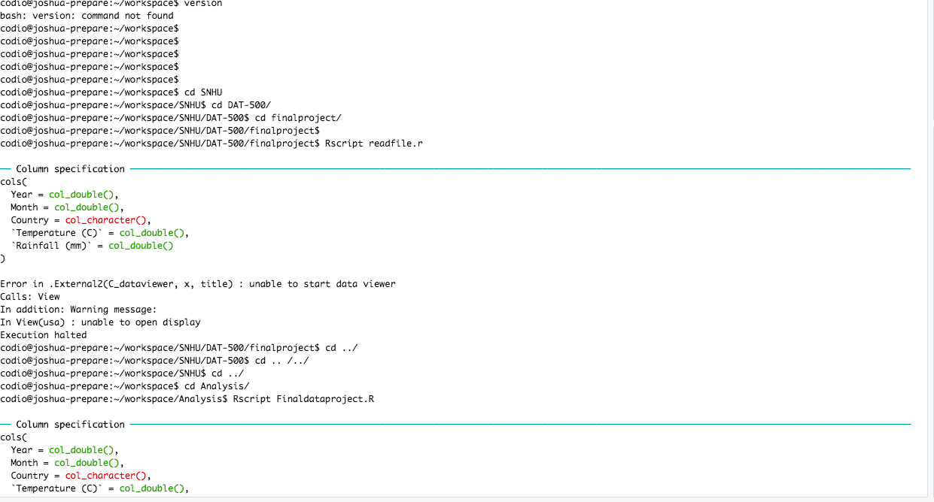
Fig 2.0

Appendix A: Data Assessment
[Insert screenshot of data assessment, similar to what was provided in the Sample Data Assessment]

Appendix B: File Organization in Linux
[Insert screenshot of file organization in Linux interface, before the files are read into RStudio]

Appendix C: Code for R program (File Output)
